**ASSIGNMENT 5**

**NALLAKALVA RISHITHA REDDY 700742428**

video

<https://github.com/rishithareddy3339/rishi_assignment/blob/master/video1152321606.mp4>

source code

<https://github.com/rishithareddy3339/rishi_assignment/blob/master/Assignment5_700742428_ML.ipynb>

1. Principal Component Analysis

a. Apply PCA on CC dataset.

b. Apply k-means algorithm on the PCA result and report your observation if the silhouette score

has improved or not?

c. Perform Scaling+PCA+K-Means and report performance.

In this we are going to apply principal component analysis where applying pca on cc dataset which is in a csv format getting it in the form of table

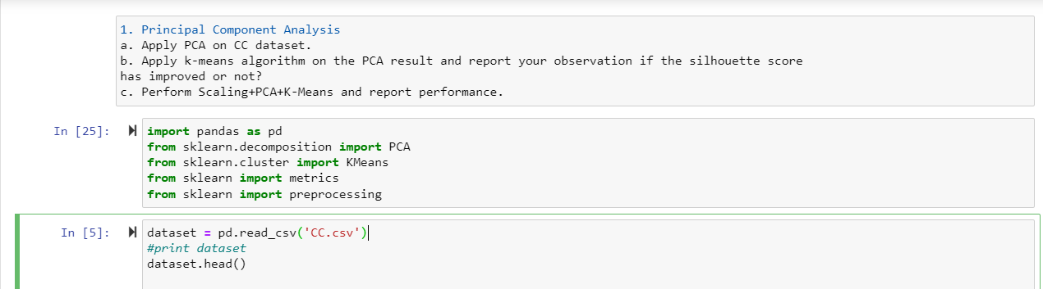

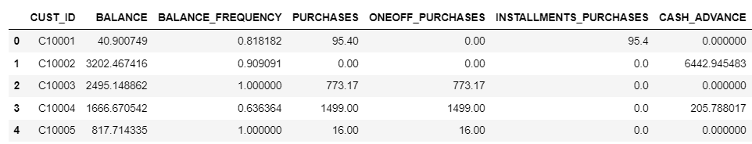

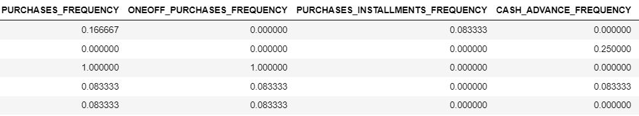

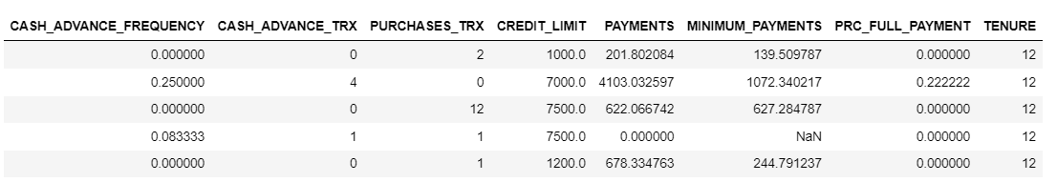

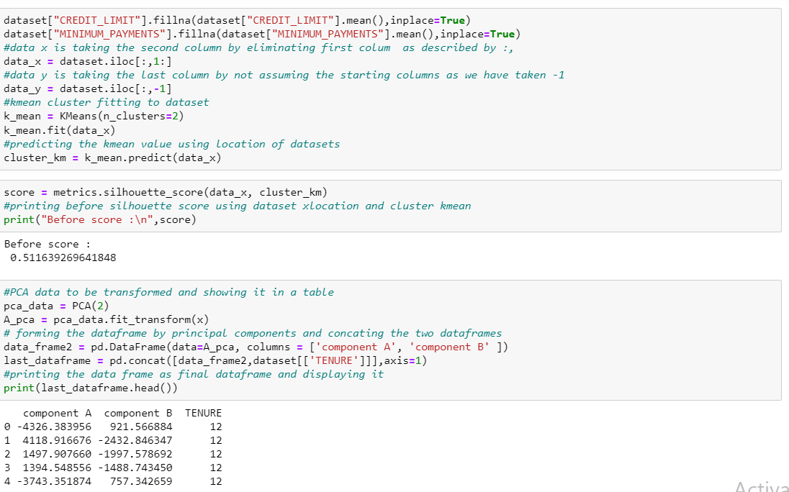

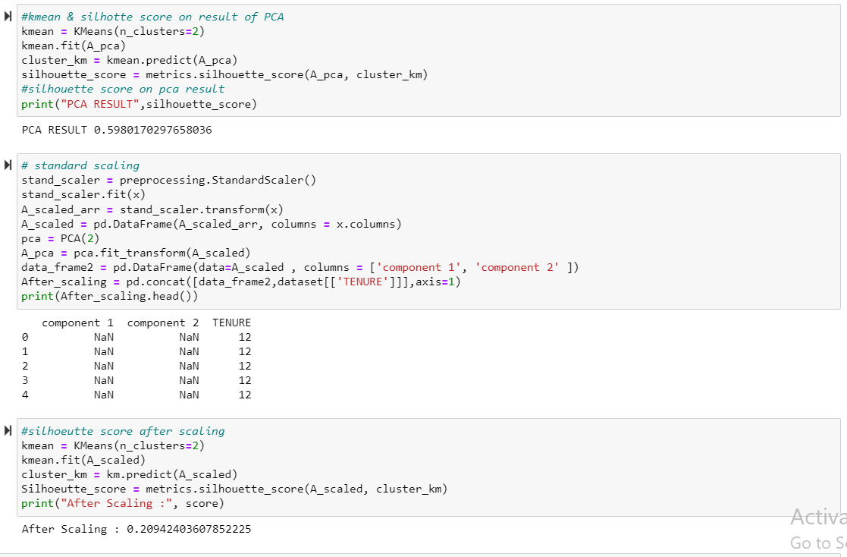

Then applying kmean algorithm on the pca result before checking the silhouette score and applying scaling and checking score after scaling and finding the silhouette score

2. Use pd_speech_features.csv

a. Perform Scaling

b. Apply PCA (k=3)

c. Use SVM to report performance

using pd_speech_features.csv we change it in a table format and then perform scaling to the pd_speech_features dataset and applying kmean cluster where k=3 and generate svm report.

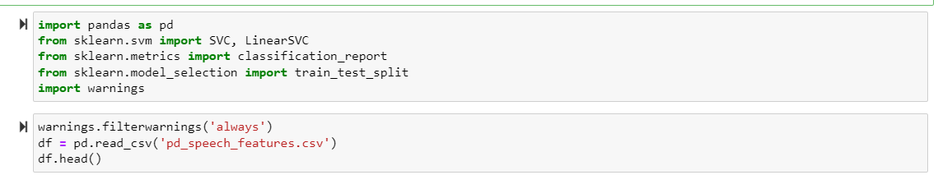

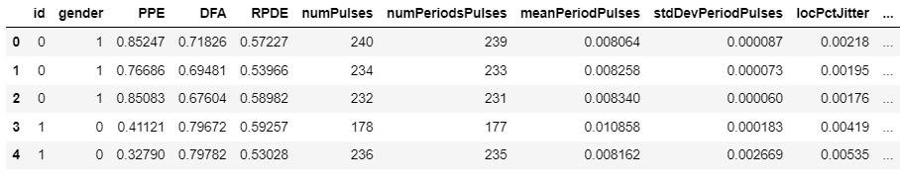

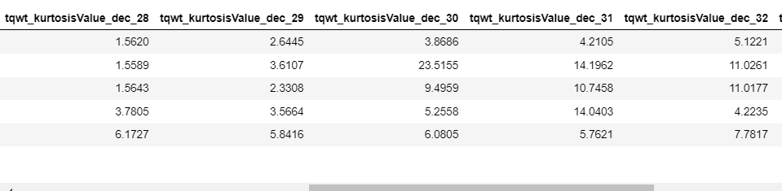

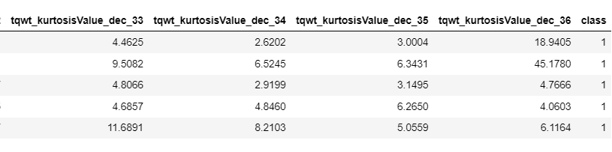

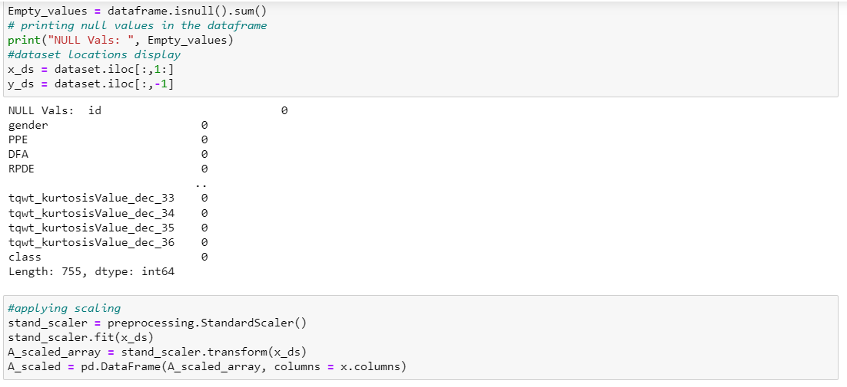

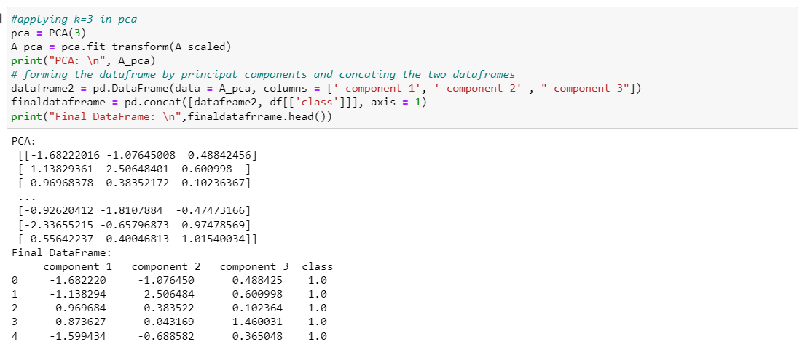

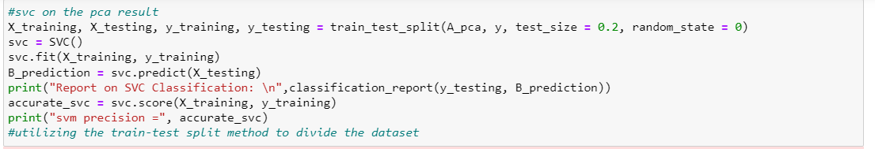

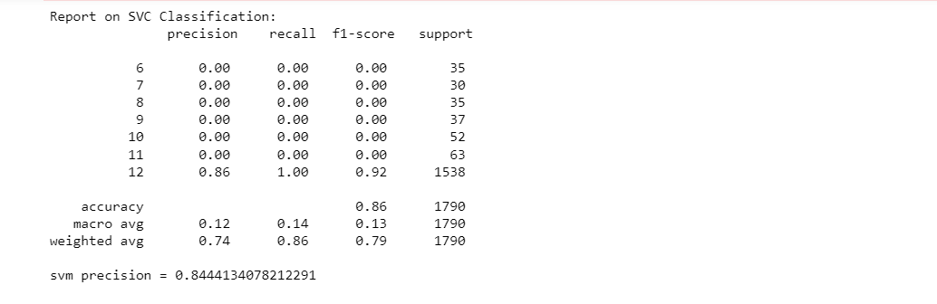

3. Apply Linear Discriminant Analysis (LDA) on Iris.csv dataset to reduce dimensionality of data to k=2.

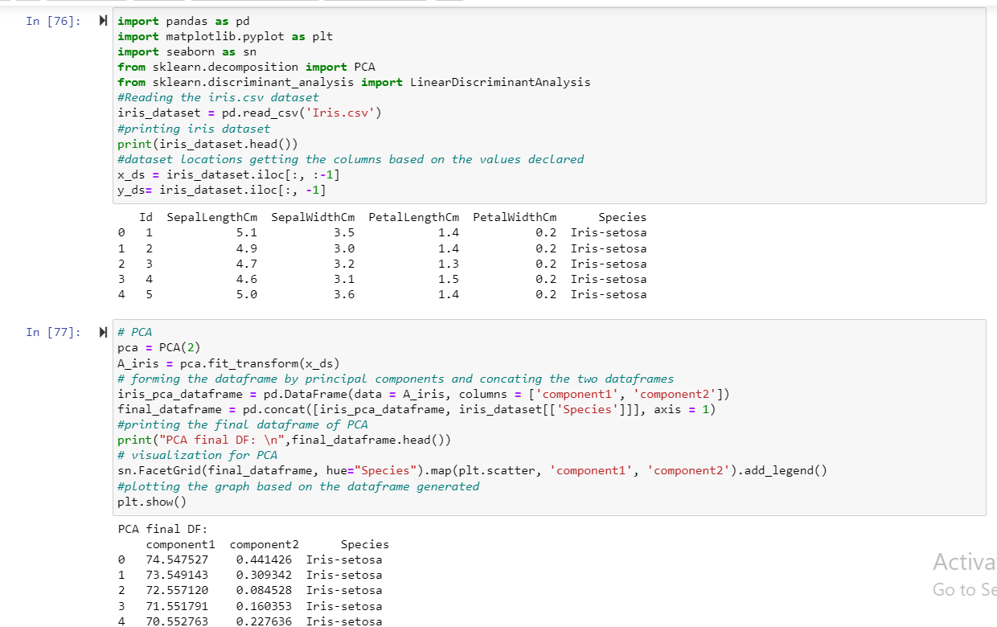

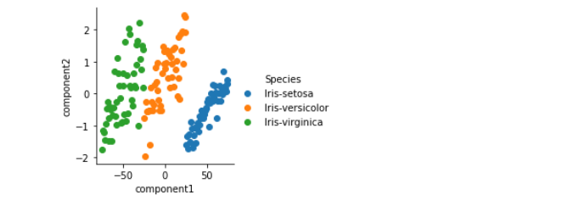

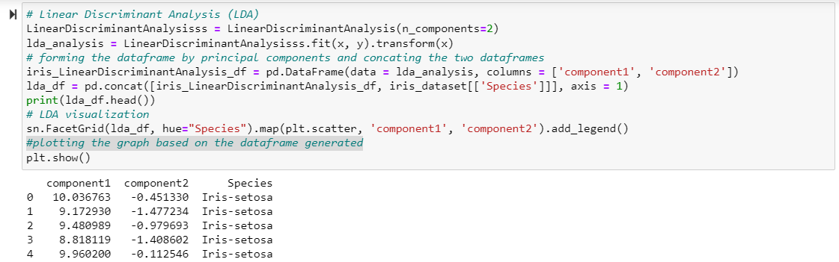

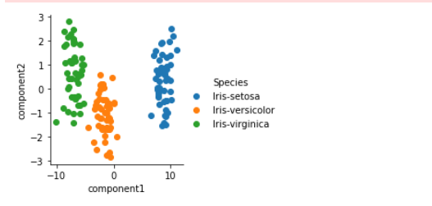

4. Briefly identify the difference between PCA and LDA

Both LDA and PCA are used to reduce the number of features. However, while LDA is supervised and will take target values into consideration as well, PCA is based on unsupervised learning and will not consider class labels. LDA also creates a new linear axis, strives for maximum categorization separability, and projects data points on that axis. We can conclude that LDA offers superior feature reduction for labelled data than PCA based on the visuals below.